Grape Leaf Disease Identification using Machine Learning Techniques

Introduction:

Indian Economy is highly dependent on agricultural productivity of the country. Grape is very commercial fruit of India. It can easily be grown in all tropical, sub-tropical and temperate climatic regions. India has got different types of climate and soil in different parts of the country. This makes grapevines a major vegetative propagated crop with high socioeconomic importance. The grape plant will cause poor yield and growth when affected by diseases. The diseases are due to the viral, bacteria and fungi infections which are caused by insects,rust and nematodes etc., These diseases are judged by the farmers through their experience or with the help of experts through naked eye observation which is not accurate and time consuming process. Early detection of disease is then very much needed in the agriculture and horticulture fifield to increase the yield of the crops. We have proposed a system that can detect and identify diseases in the leaves of the grape plants.

About abstract:

Diseases affect the growth and produce of the crops and often diffificult to control. To ensure good quality and high production, it is necessary to have accurate disease diagnosis and control actions to prevent them in time. Grape which is widely grown crop in India and it may be affected by different types of diseases on leaf, stem and fruit. Leaf diseases which are the early symptoms caused due to fungi, bacteria and virus. So, there is a need to have an automatic system that can be used to detect the type of diseases and to take appropriate actions. We have proposed an automatic system for detecting the diseases in the grape vines using image processing and machine learning technique.

Existing Methods:Features extraction using GLCM and Apply SVM algorithm

Proposed Method:The proposed system fifirst segments the ROI from the back ground using grab cut algorithm and classify the segmented leaves as healthy, balck-rot, esca and leaf blight.Figure. 1 depicts different types of disease in grape leaves.

Dataset:

Project Development Modules:

1. Collect the data
2. Basic Images processing techniques like, resize,enhance and apply filter.
3. The leaf part of the image is segmented from the background image Grabcut segmentation algorithm. This algorithm label a pixel as foreground or background using Gaussian Mixture Model (GMM) and also takes initial rectangle which is a rough segmentation between background and foreground.
4. Feature Extraction using GLCM
5. Apply SVM algorithms
6. Evaluate the SVM model
7. Predict with single image

Input of project:image of grape

Final output of project:Grape Leaf disease

Extension or improvements in project:Random FOrest algorithm

Conclusion of project:We will develop an image processing model for grape leaf disease detection.

Import packages

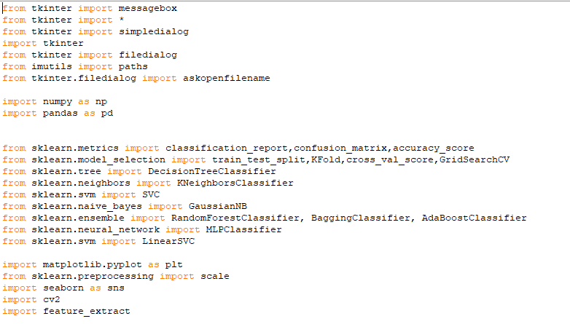

Upload dataset



Preprocessing:

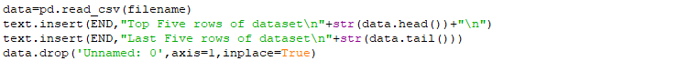

Splitting the data for training and testing



Generate machine learning models

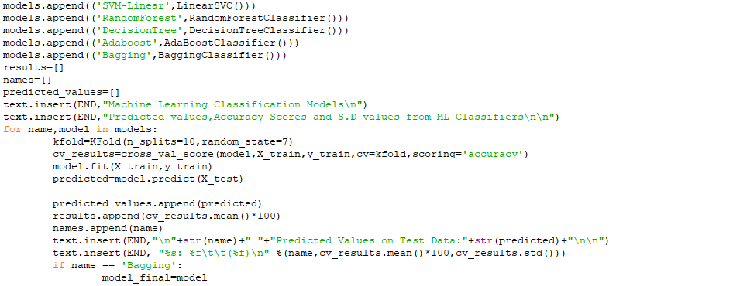

Prediction from test data,now upload test dataset

